Patrick, Apostle of Ireland
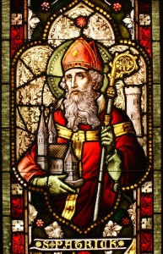
Feast Day: March 17
Canonized: Pre-Congregation
An apostle leaves home and country, family and friends to preach the good news of God’s love. God uses the apostle to reach out to pagans who believe in many gods. They do not know the beauty and goodness of the one true God. The apostle Patrick brought the great good news of the Christian God to the Irish.
Patrick was born Maewyn Succat in England, near the Scottish border, in about 389 AD. His father was a Roman magistrate in Britain. When he was 16, Irish raiders kidnapped him. They sailed back to Ireland, where Patrick became the slave of a Druid priest and worked as a shepherd. Throughout cold nights and hungry days, he dreamed of escape. Finally, after six years, he crept aboard a ship bound for Britain.
For the next 20 years, Patrick studied in France and England. At age 43 he became a bishop, and Pope Celestine called him “Patricius,” which means “father of the citizens.” In a dream, he felt God’s call to return to Ireland. Patrick said “yes” to God and sailed back to Ireland.
At first, the Druids and the kings did not welcome Patrick. (The Druids were pagan priests.) But God worked miracles through Patrick. These miracles showed people the power of the Christian God.
For 30 years, Patrick ordained priests and built monasteries in Ireland. By the time he died—in 461 at age 72—he had showed the Irish how to find Christ in one another. A famous legend about St. Patrick says he explained the Holy Trinity to the people by using a shamrock, the three-leafed plant which is today the Irish national emblem.

